Ex. No. : 08 | Date:
Register No.: 231701501 | Name: Sri Vishnu K

Boosting (AdaBoost)
Aim:
To implement Boosting technique using AdaBoost for classification of the Iris dataset.
PROGRAM:
import pandas as pd
import numpy as np
import matplotlib.pyplot as plt
from google.colab import files
from sklearn.model_selection import train_test_split
from sklearn.preprocessing import LabelEncoder, StandardScaler
from sklearn.ensemble import AdaBoostClassifier
from sklearn.metrics import accuracy_score, confusion_matrix, classification_report

# Upload dataset
uploaded = files.upload()
# Load dataset
data = pd.read_csv("Iris.csv")

# Drop Id column if present
if 'Id' in data.columns:
data = data.drop('Id', axis=1)
# Split features and target
X = data.iloc[:, :-1].values
y = data.iloc[:, -1].values

# Encode target labels
le = LabelEncoder()
y = le.fit_transform(y)

# Train-test split
X_train, X_test, y_train, y_test = train_test_split(
X, y, test_size=0.2, random_state=42
)

# Feature scaling
scaler = StandardScaler()
X_train = scaler.fit_transform(X_train)
X_test = scaler.transform(X_test)

# Create AdaBoost model
boost = AdaBoostClassifier(n_estimators=50, random_state=42)
# Train model
boost.fit(X_train, y_train)

# Predictions
y_pred = boost.predict(X_test)
# Evaluation
accuracy = accuracy_score(y_test, y_pred)
print("Accuracy:", accuracy)
print("\nConfusion Matrix:\n", confusion_matrix(y_test, y_pred))
print("\nClassification Report:\n", classification_report(y_test, y_pred))
# Plot feature importance
plt.figure()
plt.bar(range(len(boost.feature_importances_)), boost.feature_importances_)
plt.xlabel("Feature Index")
plt.ylabel("Importance")
plt.title("Feature Importance (AdaBoost)")
plt.show()

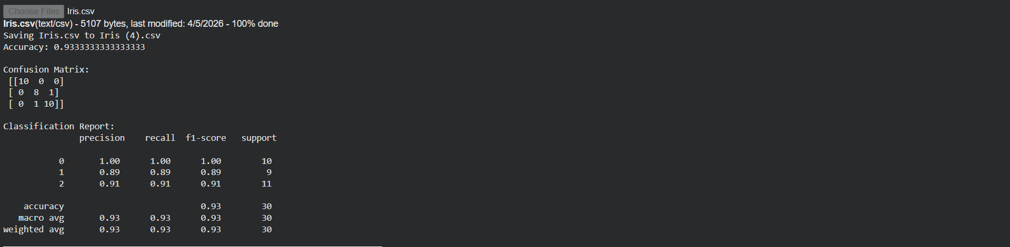

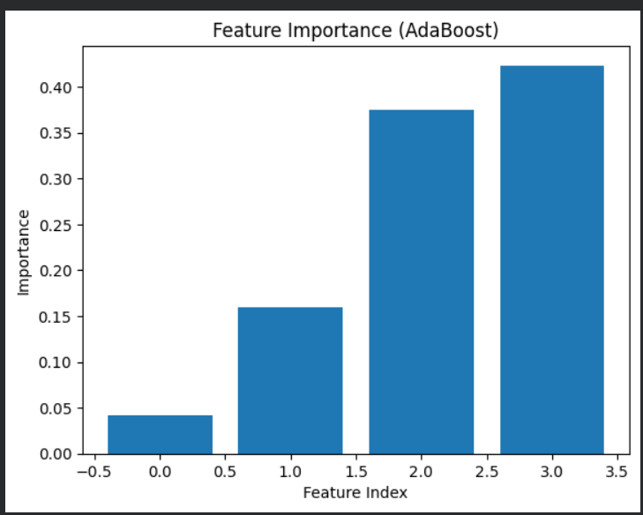

Result:
The AdaBoost model was successfully implemented and improved classification performance by combining multiple weak learners.

